
American Battery Solutions Inc.

SOC User Manual

Release Date: 03/11/2026 | Revision: V 1.0.1

(c) [2019] [American Battery Solutions]; all rights reserved. This document may contain proprietary information and may only be released to third parties with approval of management. Documents are uncontrolled unless otherwise marked; uncontrolled documents are not subject to update notification.

Table of Contents
1 Scope of this Document 2
2 Important Terms 2
3 Functional Overview 3
3.1 Block Diagram 3
3.2 Dependency 3
3.3 Initialization 4
3.3.1 Soc_initialize 4
3.4 Execution 4
3.4.1 Soc_tick 4
3.5 Provided Interfaces 4
3.5.1 Soc_get_cell_levels 4
3.5.2 Soc_get_pack_level 5
3.5.3 Soc_get_user_level 5
3.5.4 Soc_get_min 5
3.5.5 Soc_get_max 5
3.5.6 Soc_get_state 5
3.5.7 Soc_get_tau_depolar 6
3.5.8 Soc_get_batt_resttime 6
3.5.9 Soc_reset 6
3.5.10 Soc_log_fault 6
3.6 Required Interfaces 7
3.6.1 SOC_GET_BMS_MODE 7
3.6.2 SOC_GET_CELL_VOLTAGES 7
3.6.3 SOC_GET_CELL_TEMPERATURES 7
3.6.4 SOC_GET_NVM_IMPORT_STATUS 7
3.6.5 SOC_GET_REST_TIME 8
3.6.6 SOC_GET_CELL_SOHC_LEVELS 8
3.6.7 SOC_GET_CURRENT 8
3.6.8 SOC_GET_BATT_ASLEEP_TIME 8
3.6.9 SOC_GET_MIN_MAX_CELL_TEMPERATURE 8
3.6.10 SOC_NVM_READ 9
3.6.11 SOC_NVM_WRITE 9
3.7 Configuration 9
3.8 Calibrations 9
3.9 Sequence Diagrams 10
4 Source File List and Description 11
4.1 src/soc_model.c/h 11
4.2 cfg/soc_cfg.h 11
4.3 src/rtwtypes.h 11
4.4 src/soc.c/h 11
4.5 CMakeLists.txt 11
5 Resource Consumption 12
6 Test Summary 12
7 References 12

- Scope of this Document
This document outlines a detailed description of the SOC component. This outlines design details, key features, functionalities, and how to integrate this into an application.

- Important Terms

Acronym | Description
OCV | Open Circuit Voltage
SOC | State of Charge
NVM | Non-Volatile Memory
MIL | Model In Loop
SOHC | State of Health Capacity

- Functional Overview
The SOC feature calculates the battery’s State of Charge (SOC) under different operating conditions. It ensures consistent SOC information and supports proper battery usage over time.

By correcting estimation drift, it maintains stable and reliable SOC values during operation.

  - Block Diagram
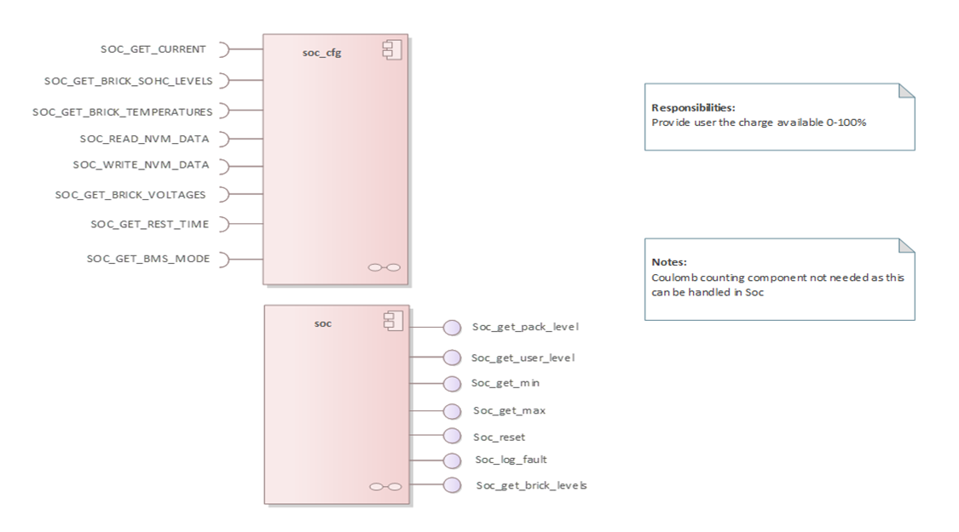
Detailed design is captured in enterprise architect model under the path design/ in the repo. Diagram below shows the class diagram for the SOC component.
Figure 1 : SOC Architecture Block Diagram

  - Dependency
This component requires the software components to be integrated alongside to be functional.
- absdef (https://bitbucket.org/americanbatterysolutions/absdef)
  - Initialization
This section provides details of the initialization of the component.

    - Soc_initialize
This routine initializes the SOC component by invoking the model-generated function soc_init().

Parameters
None.

Returns
None.

  - Execution
This section provides details about periodic functionalities to invoke from the Operating system.

    - Soc_tick
This routine is invoked periodically to execute the SOC component functionalities. This function is called cyclically and internally invokes three functions to perform input handling, model execution, and output handling.

During input handling, the Soc_read_inputs() function maps the application-layer signals to the SOC model. All required model inputs are set within this function.

Next, the main model execution is performed by calling soc_task(), which is the model-generated step function responsible for executing the SOC logic.

Finally, during output handling, the Soc_read_outputs() function reads the model outputs and maps them appropriately so they can be provided to other modules.

Parameters
None.

Returns
None.

  - Provided Interfaces
This section provides details about the interfaces provided by the component.

    - Soc_get_cell_levels
This interface provides the calculated cell-level SOC values.

Parameters
cellsoc (float32*) [out] – Pointer to an array where the cell state of charge values will be copied.

Returns
Status (status_t) - Returns ABS_OK on success; otherwise, returns ABS_PARAM_ERR.

    - Soc_get_pack_level
This interface provides the calculated pack-level SOC.

Parameters
packsoc (float32*) [out] – Pointer to the variable where the pack state of charge value will be stored.

Returns
Status (status_t) – Returns ABS_OK on success; otherwise, returns ABS_PARAM_ERR.

    - Soc_get_user_level
This interface provides the calculated user-level SOC.

Parameters
usersoc (float32*) [out] – Pointer to the variable where the user state of charge value will be stored.

Returns
Status (status_t) – Returns ABS_OK on success; otherwise, returns ABS_PARAM_ERR.

    - Soc_get_min
This interface provides the minimum SOC value.

Parameters
minsoc (float32*) [out] – Pointer to the variable where the minimum state of charge value will be stored.

Returns
Status (status_t) – Returns ABS_OK on success; otherwise, returns ABS_PARAM_ERR.

    - Soc_get_max
This interface provides the maximum SOC value.

Parameters
maxsoc (float32*) [out] – Pointer to the variable where the maximum state of charge value will be stored.

Returns
Status (status_t) – Returns ABS_OK on success; otherwise, returns ABS_PARAM_ERR.

    - Soc_get_state
This interface provides the current SOC state.

Parameters
socstate (soc_state_t*) [out] – Pointer to the variable where the SOC state will be stored.

Returns
Status (status_t) – Returns ABS_OK on success; otherwise, returns ABS_PARAM_ERR.

    - Soc_get_tau_depolar
This interface provides the calculated Tau depolarization values.

Parameters
taudepolar (float32*) [out] – Pointer to an array where the depolarization time constant values will be copied.

Returns
Status (status_t) – Returns ABS_OK on success; otherwise, returns ABS_PARAM_ERR.

    - Soc_get_batt_resttime
This interface provides the accumulated battery rest time.

Parameters
battresttime (uint32_t*) [out] – Pointer to the variable where the battery rest time value will be stored.

Returns
Status (status_t) – Returns ABS_OK on success; otherwise, returns ABS_PARAM_ERR.

    - Soc_reset
This interface resets the SOC values to the defined initial or reference value.

Parameters
resetsoc (float32*) [out] – Pointer to the variable where the reset state of charge value will be stored.

Returns
Status (status_t) – Returns ABS_OK on success; otherwise, returns ABS_PARAM_ERR.

    - Soc_log_fault
This interface provides the SOC fault status information.

Parameters
socfault (bool*) [out] – Pointer to the variable where the SOC fault status will be stored.

Returns
Status (status_t) – Returns ABS_OK on success; otherwise, returns ABS_PARAM_ERR.

  - Required Interfaces
This section provides details about the interfaces required by the component.
    - SOC_GET_BMS_MODE
This interface is used to get the BMS state (Standby, StandbyNotReady, Drive, Charge, etc.).

Parameters
battstate (battsm_state_t*) [out] – Pointer to the variable containing the current BMS state.

Returns
Status(status_t) - Returns ABS_OK on success; otherwise, returns error status.

    - SOC_GET_CELL_VOLTAGES
This interface provides cell temperature values along with their validity status.

Parameters
VoltageInfo (Dukosi_Voltage_t*) [out] – Pointer to an array of structures containing cell voltage and validity information.

Returns
Status (status_t) - Returns ABS_OK on success; otherwise, returns ABS_PARAM_ERR.

    - SOC_GET_CELL_TEMPERATURES
This interface is used to obtain the cell temperature values along with their validity status.

Parameters
TempInfo (Dukosi_Temperature_t*) [out] – Pointer to an array of structures containing cell temperature and validity information.
temptype (Dukosi_Temptype_t) [in] – Temperature type to be retrieved.

Returns
Status (status_t) - Returns ABS_OK on success; otherwise, returns ABS_PARAM_ERR.

    - SOC_GET_NVM_IMPORT_STATUS
This interface provides the status indicating whether the NVM import was successful.

Parameters
NVMimportstatus (bool*) [out] – Pointer to the variable where the SOC NVM import status will be stored.

Returns
Status (status_t) – Returns ABS_OK if successful; otherwise returns an error status
    - SOC_GET_REST_TIME
This interface provides the rest time calculated by the SOC component and stored in NVM before shutdown or sleep.
Parameters
initbattresttime (uint32_t*) [out] – Pointer to the variable where the initial battery rest time value will be stored.
Returns
Status (status_t) – Returns ABS_OK if successful; otherwise returns an error status.
    - SOC_GET_CELL_SOHC_LEVELS
This interface provides the cell SOHC values.
Parameters
cellsohc (float32*) [out] – Pointer to an array where the cell state of health values will be stored.
Returns
Status (status_t) – Returns ABS_OK if successful; otherwise returns an error status.
    - SOC_GET_CURRENT
This interface provides the measured battery current in amperes (A).

Parameters
current (float32*) [out] – Pointer to the variable where the measured battery current value will be stored.

Returns
Status(status_t) - Returns ABS_OK on success; otherwise, returns ABS_PARAM_ERR.

    - SOC_GET_BATT_ASLEEP_TIME
This interface provides the battery sleep time accumulated by the RTC.

Parameters
battasleeptime (uint32_t*) [out] – Pointer to the variable where the battery sleep time value will be stored.

Returns
Status (status_t) – Returns ABS_OK if successful; otherwise returns an error status.

    - SOC_GET_MIN_MAX_CELL_TEMPERATURE
This interface provides the minimum and maximum cell temperatures along with their corresponding cell IDs.

Parameters
min_max_temperature (Dukosi_Temperature_result_t*) [out] – Pointer to the structure containing minimum and maximum cell temperature values and their associated cell IDs.
temptype (Dukosi_Temptype_t) [in] – Temperature type to be retrieved.

Returns
Status(status_t) - Returns ABS_OK on success; otherwise, returns ABS_PARAM_ERR.

    - SOC_NVM_READ
This interface provides the initial SOC value stored in NVM.

Parameters
initsoc (float32*) [out] – Pointer to the variable where the initial state of charge value will be stored.

Returns
Status (status_t) – Returns ABS_OK if successful; otherwise returns an error status.

    - SOC_NVM_WRITE
This interface provides access to store the calculated SOC data into NVM.

Parameters
socnvm (float32*) [in] – Pointer to the SOC value to be written to NVM.

Returns
Status (status_t) – Returns ABS_OK if successful; otherwise returns an error status.

  - Configuration
Table 2 below lists out the configuration parameters for the component.

Define Name | Description | Value
SOC_CELLS_IN_PARALLEL | This parameter represents the number of cells connected in parallel | 48
SOC_NUM_OF_CELLS | Total number of cells | TBD
SOC_LUT_TEMP_ARRAY_SIZE | Lookup table temperature array size | 13
SOC_LUT_SOC_ARRAY_SIZE | Lookup table soc array size | 21
SEC_TO_MILLISEC | Conversion factor to convert seconds to milliseconds. | 1000
FRACTION_TO_PERCENT | Conversion factor to convert fraction to percent. | 100
PERCENT_TO_FRACTION | Conversion factor to convert percent  to fraction. | 0.01
AH_TO_COULOMB | Conversion factor to convert ampere-hour to coulombs. | 3600
Table 2 – Configurable Values
  - Calibrations
Table 3 below lists out the calibration parameters for the component.
Define Name | Description | Value
KeSoc_frc_SocMaxLim | This parameter defines the upper limit used to clamp the SOC value. | 1.0
KeSoc_frc_SocMinLim | This parameter defines the lower limit used to clamp the SOC value. | 0.0
KeSoc_nu_RestTauFactor | This parameter defines the time constant factor used for battery rest detection response time. | 3.0
KeSoc_sec_SampleTime | This parameter defines the sample time of the SOC algorithm in milliseconds. | 0.01
KeSoc_A_RestingCurrent | This parameter defines the current threshold below which the battery is considered at rest. | 4
KeSoc_V_TocMaxCellVolt | This parameter defines the maximum cell voltage threshold for confirming top-of-charge reset. | 4.5
KeSoc_V_TocAvrgCellVolt | This parameter defines the average cell voltage threshold for confirming top-of-charge reset. | 4.5
KeSoc_ms_SocTocSetTi | This parameter defines the minimum wait time required to trigger the top-of-charge reset. | 10000
KeSoc_frc_TopOfChrgRst | This parameter defines the calibrated SOC value set during top-of-charge reset. | 1
KeSoc_ms_SocBodSetTi | This parameter defines the minimum wait time required to trigger the bottom-of-discharge reset. | 10000
KeSoc_V_BodMinCellVolt | This parameter defines the minimum cell voltage threshold for bottom-of-discharge reset. | 2.993
KeSoc_frc_BotmOfDchRst | This parameter defines the calibrated SOC value set during bottom-of-discharge reset. | 0
KeSoc_nu_SocCorrnFac | This parameter defines the gain used to blend OCV-based SOC with coulomb-counted SOC. | 0.5
KeSoc_frc_UserSocMaxLim | This parameter defines the upper limit used to clamp the user SOC value. | 0.99
KeSoc_frc_UserSocMinLim | This parameter defines the lower limit used to clamp the user SOC value. | 0.014
KaSoc_pct_socLut | This parameter provides an array of SOC reference values for the lookup operation.
KaSoc_V_ocvLut | This parameter defines the array of OCV voltage values used for lookup.
KaTmpmnt_degC_tempLut | This parameter defines the array of temperature values used for lookup operations.
KaSoc_sec_tauDepolarLut | This parameter defines the array of Tau depolar values used for lookup operations.
KeSoc_Ah_capacity | This parameter represents the nominal capacity of a cell. | 4.93
Table 3 - Calibration Values
Note: The configuration & calibration values currently used in the software are provided for reference purposes only. They are not yet confirmed and are subject to validation and change.

  - Sequence Diagrams
N/A.

- Source File List and Description
The following sections outline the source files needed to realize the SOC component.

  - src/soc_model.c/h
This is the file set that implements the functionality of the SOC component.

  - cfg/soc_cfg.h
This is the cfg file used by the application to integrate the SOC component to the application.

  - src/rtwtypes.h
Contains type definitions required by the generated code, such as fixed-width integer types, logical types, and other basic data type definitions used across all generated modules.

  - src/soc.c/h
This file serves as an interface wrapper between the generated Simulink SOC model and the application layer, exposing functions for initialization, periodic execution, and input/output signal handling.

  - CMakeLists.txt
This is cmake configuration file to build the SOC software component. Both src and cfg directories have this file to build the directories separately and integrate.
- Resource Consumption
Resource | Usage
RAM | TBD
ROM | TBD
CPU Bandwidth | TBD
Table 4

- Test Summary
The following sections present the MIL and unit test reports.

MIL Testing
For MIL, the complete SOC model and individual subsystems were tested using various input scenarios to verify functionality and performance. Test reports and test inputs are uploaded under the path test/mil/ in the soc bitbucket repo.

Unit Testing
Unit testing was performed on the MATLAB-generated C code to validate the algorithm implementation at the code level.
Test reports and test inputs are uploaded under the path test/unit/ in the soc bitbucket repo.

MISRA + BARR-C
The following section presents the Model Advisory Report generated in MATLAB Simulink, which includes checks for Simulink modeling guidelines, MISRA compliance, and ISO 26262 requirements. Generated model advisor report is uploaded under the path docs/ in the soc bitbucket repo.

- References
N/A

